IERG1000 LAB REPORT 2

NAME : CHAN TAI MAN, SID : 110011000, Email : [ctm122@ie.cuhk.edu.hk](mailto:ctm122@ie.cuhk.edu.hk)

### Task 3.1

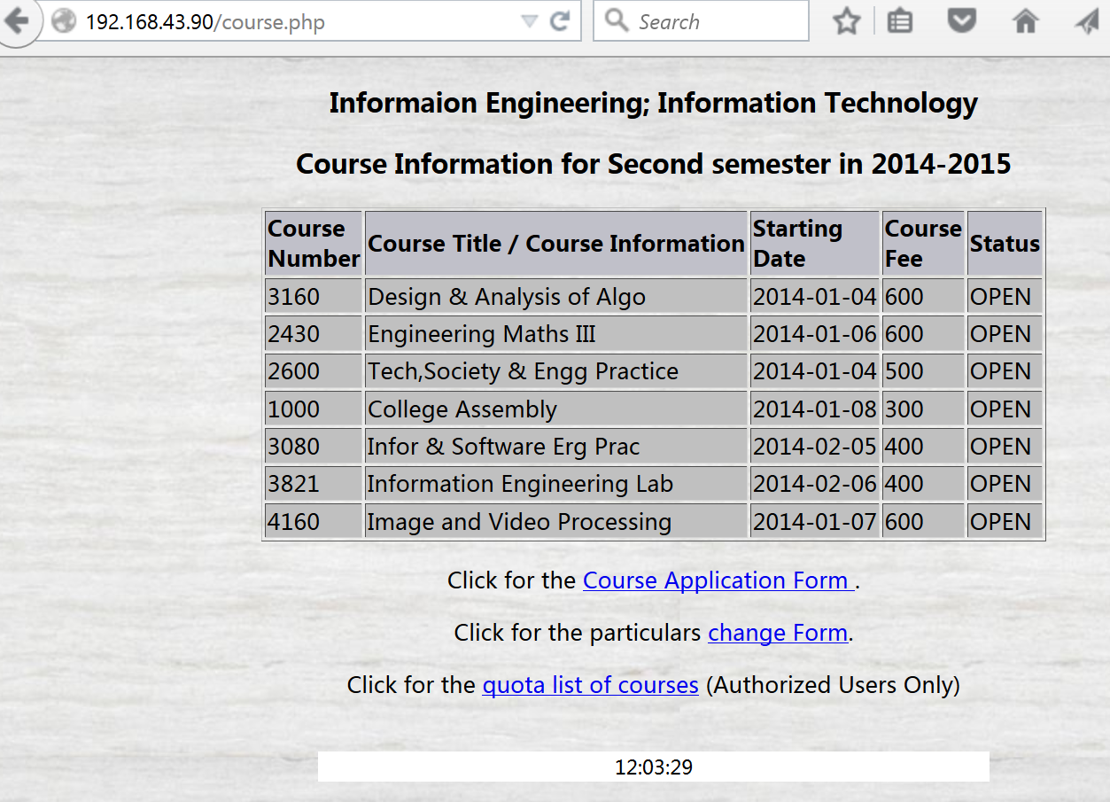

### Task 3.2

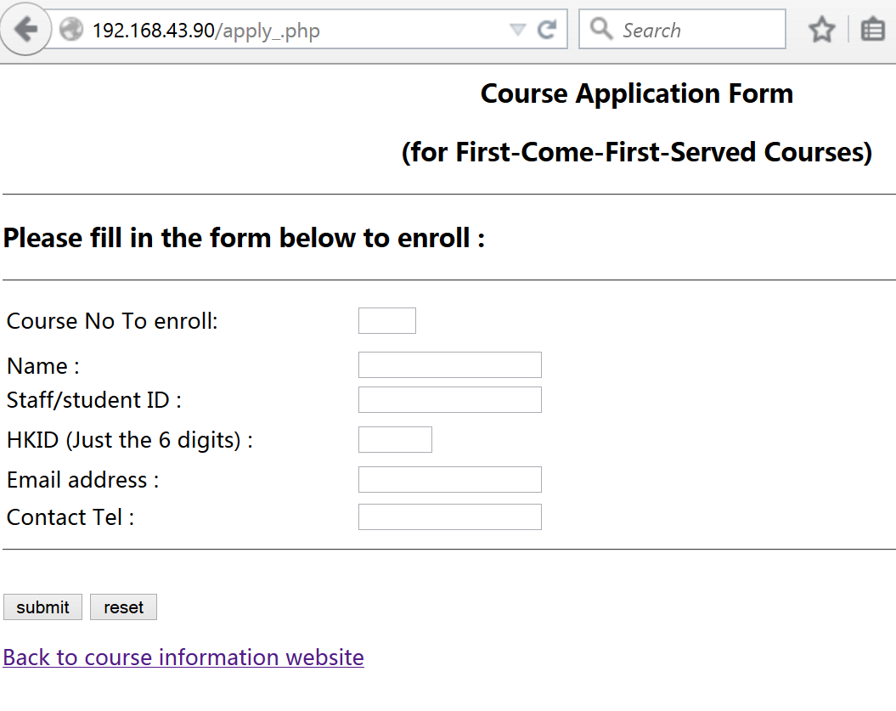

### Task 3.3

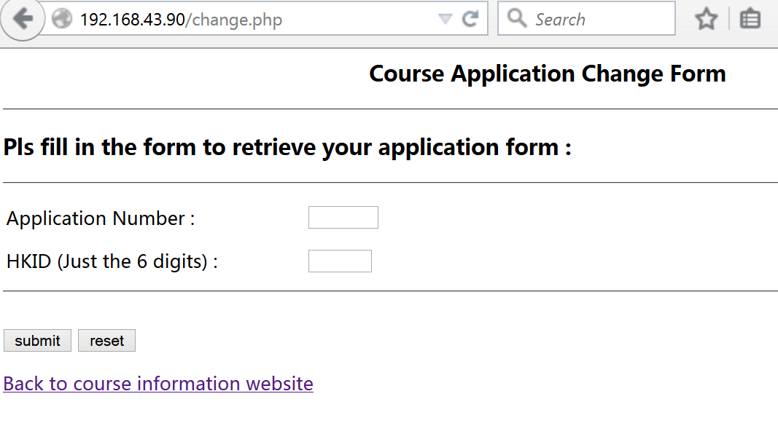

### Task 3.4

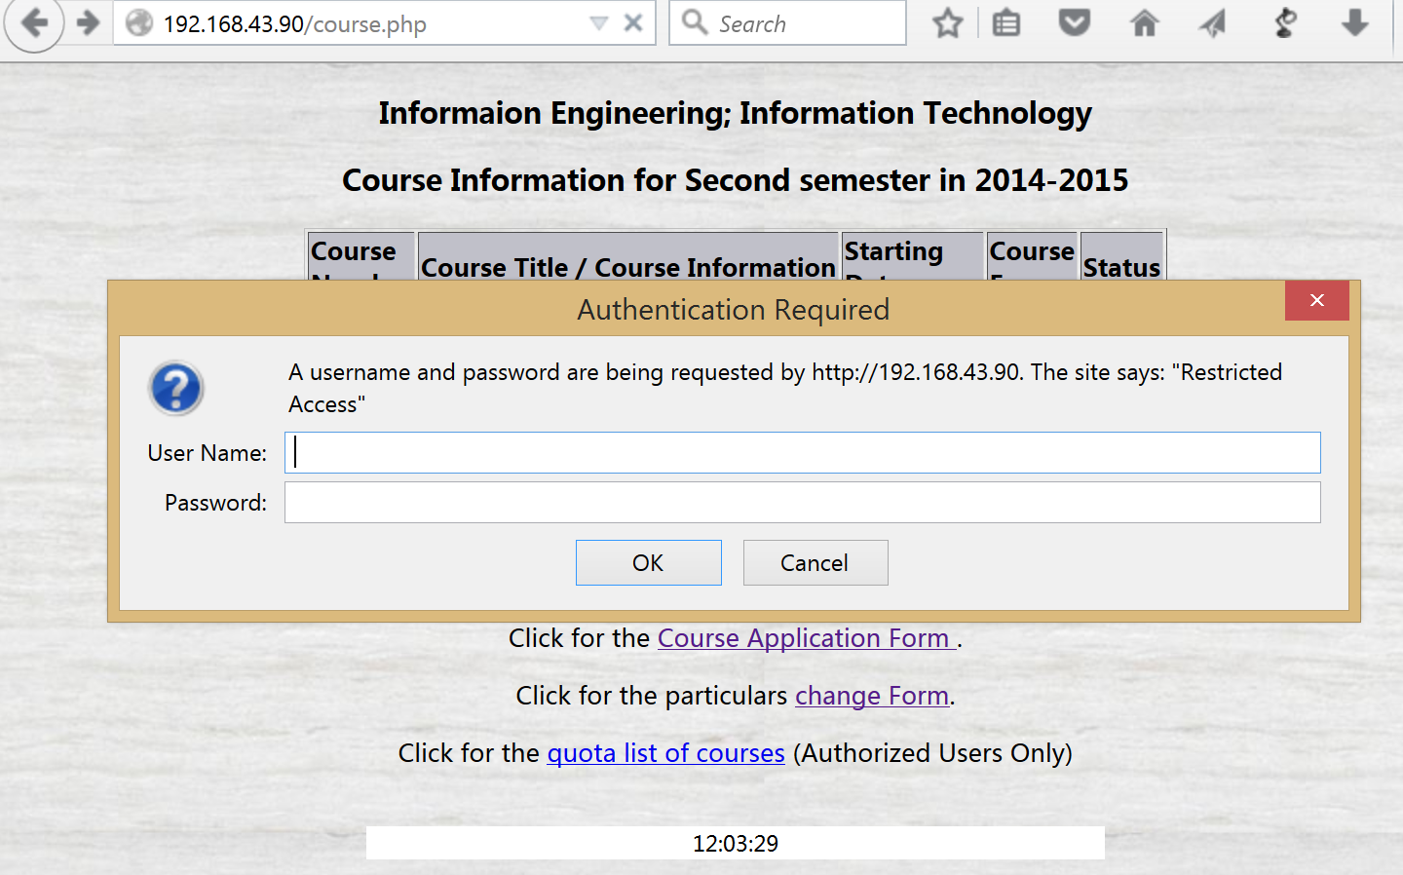

|  |
| --- |
| Put apply.php source code below : |
| Put change.php source code below: |